PRESENTING CLINICAL SIGNS
History: Eating very little. Not drinking. No vomiting or diarrhea. Acute blindness with dilated pupils. Concern for SARDS or neurologic dz. Mild lumbar pain. Tried 10-day course of Galliprant and gabapentin, no improvement. Bradycardic.
-Abnormal PE/Chem/CBC/UA Results: (8/11/21) CBC/Superchem/T4 wnl. SDMA 12. 4/13/21-WNL USG >1.050

ELECTROCARDIOGRAPHIC FINDINGS *Note: Single lead ECGs are evaluated as a rhythm strip. Morphology/MEA cannot be definitively commented on.
A single lead ECG is available; 25mm/s, 20mm/mV. The average heart rate is 110bpm (range 44-125bpm). The rhythm is sinus in origin, with a p for every QRS complex and vice versa. The P and QRS morphologies are positive. No ectopic beats, pauses or other dysrhythmias observed.
ECG diagnosis: Respiratory sinus arrythmia with significant bradycardia. Rule out Cushings reflex v high vagal tone versus sinus node dysfunction.

ECHOCARDIOGRAM FINDINGS
2D, m-mode, color flow and doppler imaging is available. Diffuse thickening of mitral valve leaflets with no prolapse into the left atrial lumen. Trace mitral regurgitation with no left atrial dilation. Normal MR velocity. Normal LV diameter with adequate myocardial function. The tricuspid valve appears mildly thickened with mild tricuspid regurgitation. Normal velocity. Normal right atrial and ventricular diameter and morphology indicating no overt evidence of pulmonary arterial hypertension. The pulmonic and aortic valves are normal in morphology and mobility. Normal pulmonic and aortic outflow velocities with laminar flow. No obvious aortic or pulmonic insufficiency. No pericardial or pleural effusion noted. No obvious cardiac masses.

CARDIAC CHART
CANINE  CARDIAC  PARAMETERS | MR  VMAX  (m/s) | TR  VMAX  (m/s) | LA/AO  (Boon method) | LA/AO  (Heart Base; Swe) | FS  (%) | EF  (%) | EPSS  (cm)
NORMAL PARAMETER | 4.5-5.5 | <2.7 | 1.3 | <1.6 | 28-40 | 40-100 | <0.6
PATIENT | 5.8 | 2.1 | NM | 1.3 | 34 | 64 | 0.55
CANINE  CARDIAC  PARAMETERS | HR  (BPM) | AV  VMAX  (m/s) | PV  MAX  (m/s) | BODY WEIGHT  (kg) | LA  2D short axis  Base view  (cm) | LVIDd  Avg; 2D and m-mode short axis  (cm) | LVIDs  Avg; 2D and m-mode short axis  (cm)
NORMAL PARAMETER | 50-100 | 0.7-1.7 | 0.7-1.6 | BELOW | BELOW | BELOW | BELOW
PATIENT | NM | 1.7 | 0.63 | 36.7 | 2.87 | 4.3 | 2.8
*Normal chamber parameters expressed as a mean value (SD) |  |  |  | 3 | 1.27 (5.3) | 2.46 (2.46) | 1.36 (5.5)
BODY WEIGHT DEPENDENT PARAMETERS  *Note: All measurements based upon multi-modal images and methods. An average value is reported.  Adapted from June Boon, Veterinary Echocardiography, 1998  Rishniw M and Hollis NE, J Vet Intern Med 2000; 14:429-435  Hansson et al, Vet Rad and Ultrasound 2002  Bonagura et al. Echocardiography: principles of interpretation, Vet Clin North Am 15:1177, 1995 |  |  |  | 5 | 1.40 (4.5) | 2.74 (5.2) | 1.60 (4.7)  2.06
 |  |  |  | 10 | 1.50 (3.8) | 3.27 (3.5) | 2.06 (3.1)
 |  |  |  | 15 | 1.83 (2.0) | 3.71 (2.4) | 2.43 (2.1)
 |  |  |  | 20 | 2.02 (1.9) | 4.14 (2.2) | 2.80 (2.0)  3
 |  |  |  | 25 | 2.18 (2.4) | 4.48 (2.9) | 3.10 (2.5)
 |  |  |  | 30 | 2.33 (3.3) | 4.83 (3.9) | 3.39 (3.4)  3.69 (
 |  |  |  | 35 | 2.48 (4.3) | 5.17 (5.0) | 3.69 (4.5)
 |  |  |  | 40 | 2.62 (5.2) | 5.48 (6.1) | 3.96 (5.4)
 |  |  |  | 50 | 2.88 (7.1) | 6.07 (8.3) | 4.46 (7.4)

INTERPRETATION OF THE FINDINGS & FURTHER RECOMMENDATIONS
Chronic degenerative valve disease causing trace mitral and mild tricuspid regurgitation. Lack of significant left atrial enlargement indicates the current risk for complication is low. No concurrent issues such as systolic dysfunction or pulmonary hypertension are noted in this study.

The ECG shows a significant bradycardia with presumably a respiratory sinus arrythmia. Given the case history there is suspicion that this reflects the Cushings reflex (i.e., bradycardia secondary to neurologic disease/increased ICP). Assuming this is the case, treatment of the primary issue should improve the heart rate. Other possibilities include high vagal tone for any other cause or potentially sinus node dysfunction (less likely given the history). No treatment is warranted as this is suspected to be a secondary phenomenon rather than a primary cause. Follow up is certainly advised, particularly should any collapse episodes be noted in the future.

In a dog with no significant left atrial enlargement, no cardiac medications are clearly indicated. Assessment of progression in the future will help predict long term prognosis, which is highly variable at this stage (B1). Omega fatty acid supplementation and mild salt restriction may be of some long-term benefit. Monitor for development of a cough, labored breathing, exercise intolerance or collapse episodes.

No cardiac contraindication for general anesthesia prior to chamber enlargement.

PLAN
Reassess heart rate/ECG once neurologic signs have resolved. Reassess ECG and/or holter monitor if any syncope develops in the future.

Recommend conservative monitoring with a recheck echocardiogram in 6-12 months, sooner if any development of clinical signs.

IMAGES
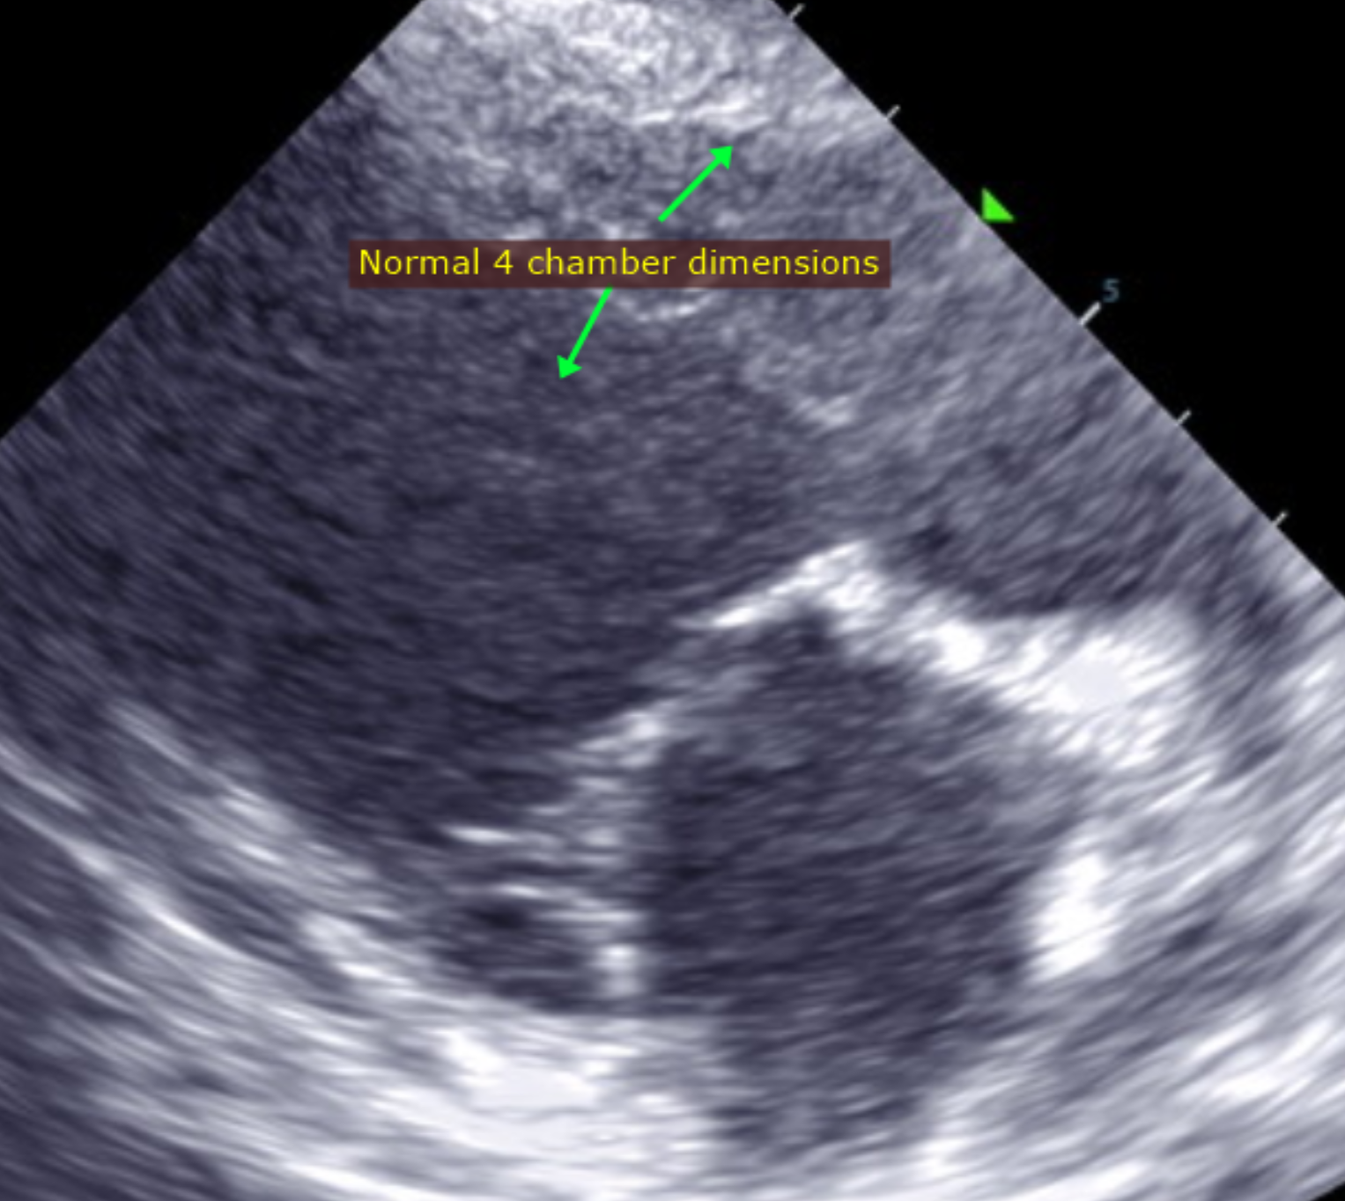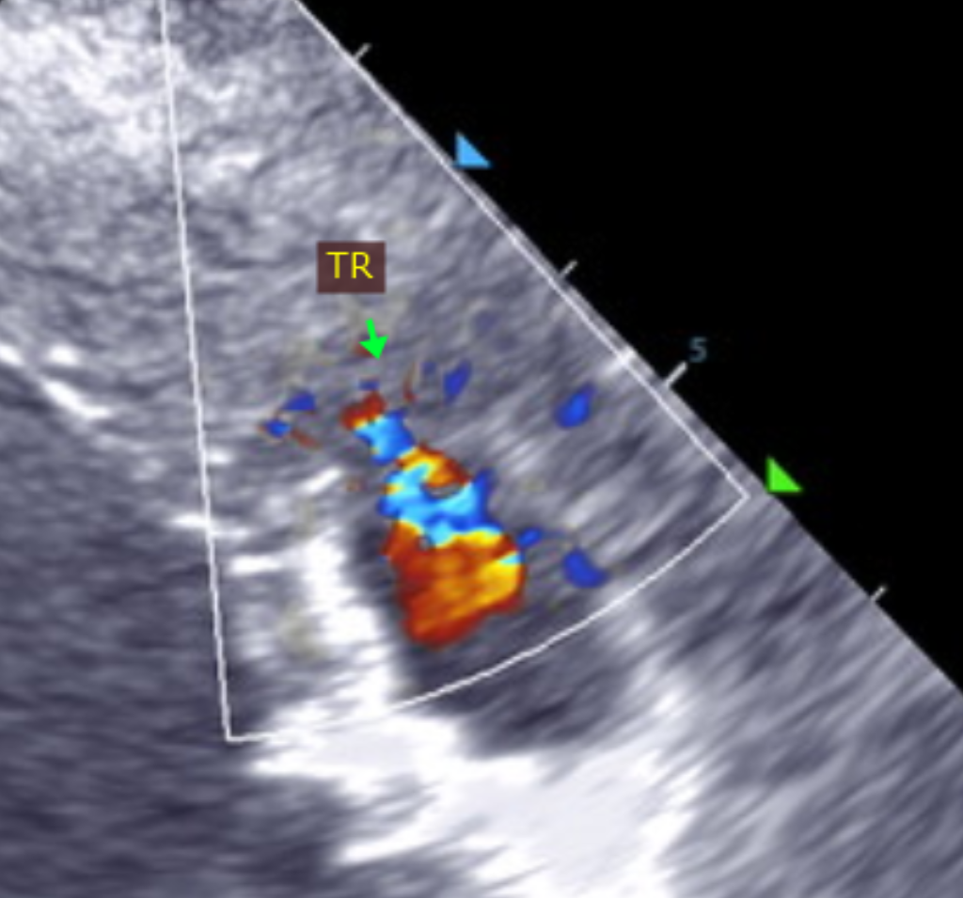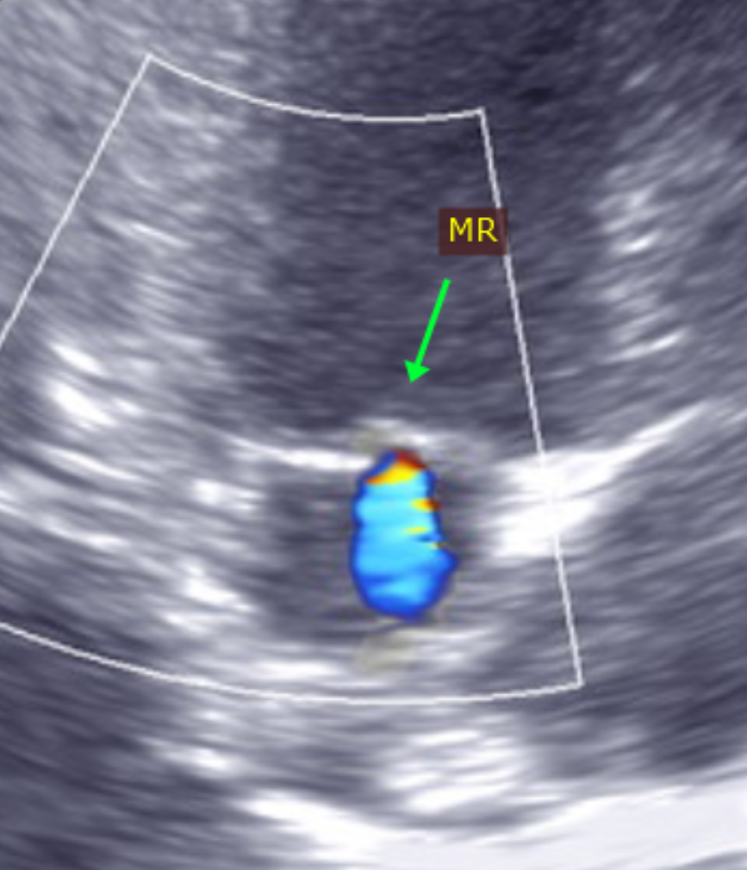
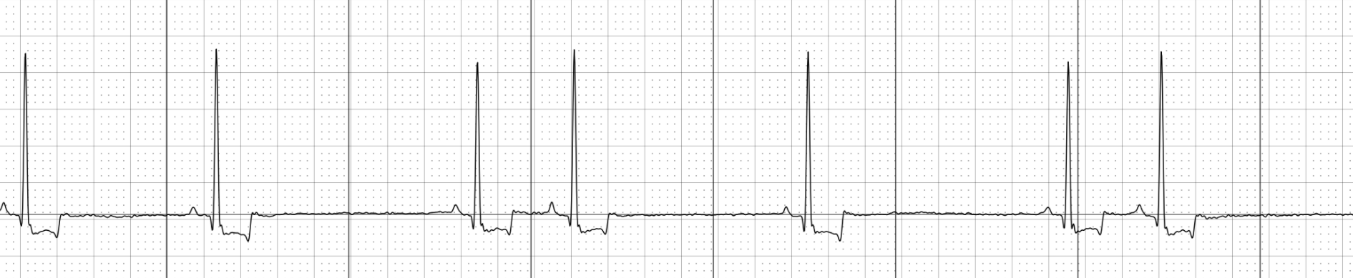

The information and recommendations provided are based on the images presented by the referring veterinarian. No evaluation can be communicated regarding pathology that was not visible in the image/video clips provided.

Thank you for this referral. This report was generated using transcription software, and minor dictation errors may be present. If the clinical or image interpretation does not parallel your findings or if I can be of any further assistance, please contact me.

Maggie Machen Lamy, DVM
Diplomate of the American College of Veterinary Internal Medicine (Cardiology)
info@sonopath.com

